**Line Graph**

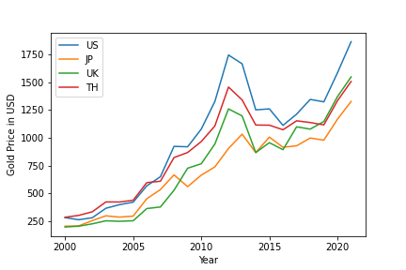

A line graph shows the evolution of one or several numerical values.

Line graph is one of the most used graphs in python. In line graph, It is easy to analyze the data.

In above line graph, it shows the gold price in Dollar (USD) from the year 2000 to 2020. Here I have taken the four countries which are Unites States (US), Japan (JP), United Kingdom (UK) and Thailand (TH).

I have compared the gold prices in USD of these four countries from 2000-2020. I have used gold prices in USD in x-axis and Year in y-axis.

Here, we can see that gold price in US is increasing when reaching 2020. Where in second place, it stands UK and then there comes TH and JP. But if we are looking at 2000, TH is most expensive in gold price and then other countries comes in.`

**Histogram Graph**

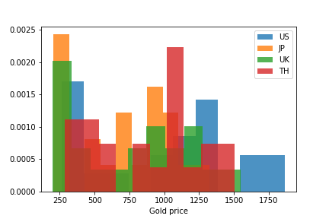

A histogram is a great tool to see frequency distribution of data.

It is a one of mostly used graph in python because histogram is easy to understand.

**Box Graph**

